W-11

**YEAR 12 PHYSICS**

**ASS. 3 - MOMENTS AND EQUILIBRIUM**

**NAME: TOTAL: **

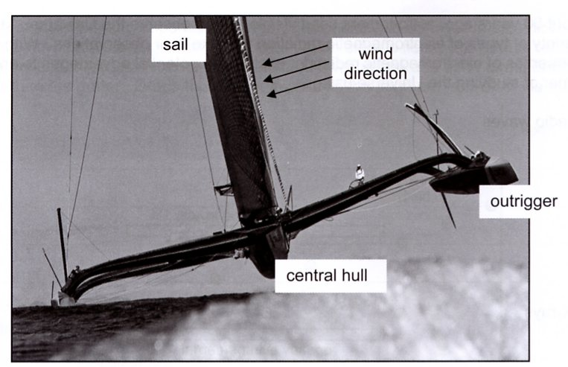**DUE DATE:**

1. The photograph shows the yacht BMW Oracle,

which has both a length and width of 28 m.

***Estimate*** the torque, exerted by the wind blowing

on the sails, that would just begin to tip the

BMW Oracle as shown. The sail has a mass of

3.5 x 103 kg, the central hull 1.0 X 103 kg and

each outrigger 0.5 x 103 kg.

(3)

2. A circus performer of mass 65.0 kg is walking along a high wire. The wire sags under the weight of

the performer and makes an angle of 15.0 ° with the horizontal, as shown in the diagram. Calculate

the tension in the wire between the poles.

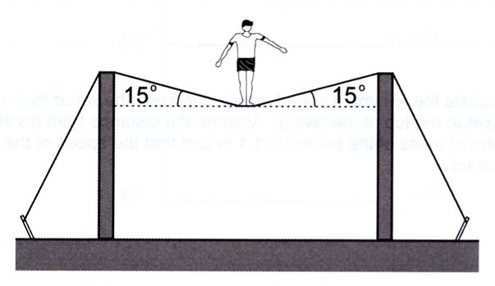

(3)

3. An empty pan has a mass of 4.50 x 102 grams without the handle. The handle has a mass of 50.0 g.

The pan is being held at the end of the handle. Assume that both the pan and handle are uniform. The

pan has 2.00 kg of water in it. The water is uniformly distributed in the pan and is not moving.

What moment should be supplied by the person holding the pan to stop it from tilting? You should

give the size and direction of this moment.

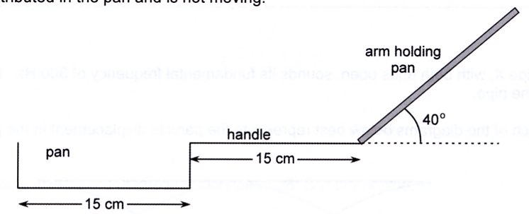

(3)

4. A boy stands on the end of a rigid uniform plank lying on a brick wall . ***Estimate*** the minimum mass

of the plank. Justify your answer.

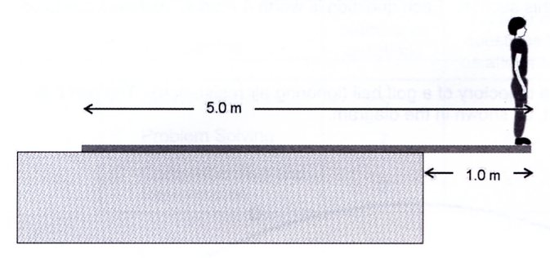

(3)

5. If you try to move an armchair sideways by pushing near the top of it (force T), it will tumble over,

but if you push nearer the middle of one side (force M) it will slide along. Explain.

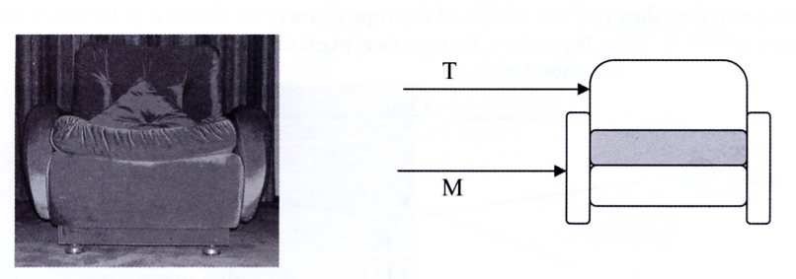

(3)

6. After sustaining an injury in a football match, a 1.80 m tall player is carried on a stretcher by two

attendants, Simon and Paul. The mass of the player is 80.0 kg and the mass of the stretcher is 5.00 kg.

The centre of mass of the player is 1.08 m from the player's feet. The centre of mass of the stretcher is

90.0 cm from the player's feet Calculate the force that Simon exerts as they carry the injured player.

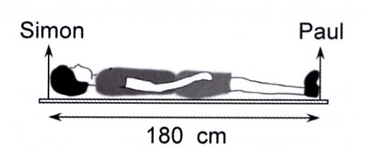

(3)7. A concrete bridge structure is being built. It consists of vertical pillars that support horizontal

platforms.

(a) The section of bridge platform labelled PQ on the diagram below is in equilibrium. Draw and

label the forces acting on the platform.

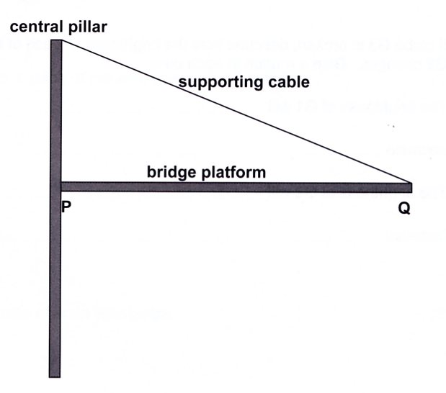

(3)

The diagram below shows a heavy truck moving along the bridge during construction. The

distances in metres from the central pillar are shown on the diagram. The centre of mass of the

truck is at the 10.0 m mark and the bridge platform extends to 35.0 m from the pillar, the top of

which is 17.5 m above the platform. The section of bridge platform shown has a mass of

4.20 x 102 tonnes and the truck has a mass of 50.0 tonnes.

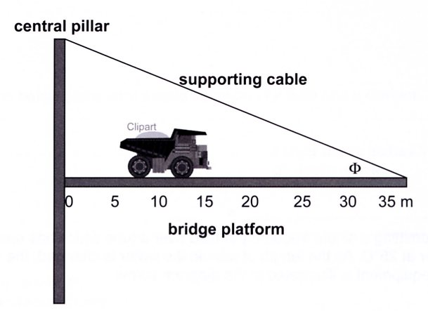

P

Q

(b) Calculate the angle 

(1)

(c) By taking moments about a suitable point calculate the tension in the cable.

(3)

(d) Calculate the force exerted at point P by the central pillar onto the bridge when the truck is at

the position shown.

(3)

8. A springboard diver with a mass of 62.5 kg is standing on the end of a diving board as shown below.

The springboard has a mass of 1.20 x 102 kg. A clamp at C holds the end of the board in place.

Assume for parts (a) and (b) only that the springboard is uniform and rigid ( i.e. does not bend).

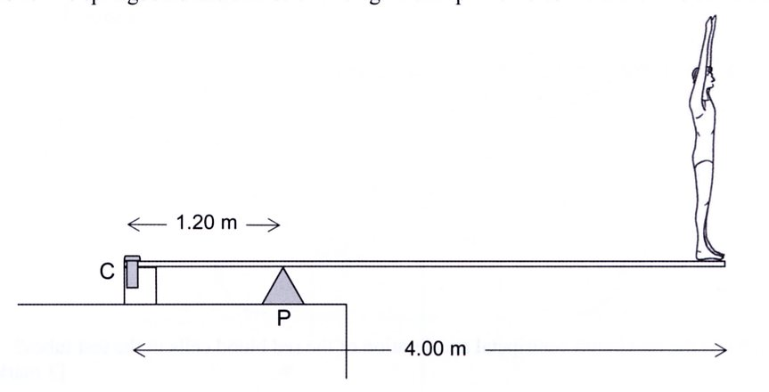

(a) On the diagram, use arrows to show the direction of the forces on the board due to the pivot

point (P) and the clamp (C).

(2)

(b) Calculate the forces acting on the clamp (C) and the pivot point (P) when the diver is standing

on the end of the board .

(4)

9. A support for a hanging pot plant consists of a 0.500 m long uniform rigid boom AD of mass

0.750 kg pivoted at the lower end and supported by a light rope to the wall as shown in the figure below. The angles are as shown.

The angles ABC and BAC are 45.0˚ and 60.0˚ respectively and the support cable BC is connected to

the mid-point of AD at C. The mass of the pot plant and basket is 2.20 kg.

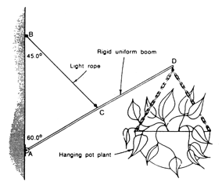

(a) Calculate the tension in the rope.

(3)

(b) Calculate the magnitude and direction of the force exerted by the wall on the boom at the

point A.

(3)

(c) Describe how the magnitude and direction of the force on A would alter if angle BAC were to

be increased.

(2)